To do

Gustavo
aim 3 – what experiments? which proteins
check experiments etc
Christine
sequence / structure features
write write write
Dennis
aim 2: model description
preliminary results using similar models, anything available from previous work?

Issues
DS: Is it ok to talk about ‘priors’ and organize the experiments as it was in the Bayesian model?
GS/CV: Dig out more data on sequence features that are predictive?
DS: Student for aim 2?
DS: Do we need a ‘no OX’ condition?

Project Summary

1. Title
Predicting destruction: A quantitative model for protein degradation following oxidative stress

2. Senior personnel
Dr. Christine Vogel – PI (NYU); Dr. Dennis Shasha – Collaborator (NYU) Should I be a co-PI? I don’t care particularly, but that is what I am in the Gloria grants. It might make reviewers think I’m more seriously involved

3. Intellectual merit
Predictive modeling of protein degradation on a proteome-wide scale. Genome-wide molecular technologies have transformed biology, enabling researchers to quantify thousands of mRNAs and proteins under many conditions. A fundamental insight from these studies postulates that degradation is as important as transcription [do we need a ref here?] – but our understanding of the regulation of protein degradation still has many gaps [and ref here? Or can you say something even stronger, e.g. understanding of protein degradation is essentially only that we know it happens]. In this proposal, proteome-wide experimental, sequence, and protein structural information will be integrated to build the first predictive model of protein degradation, at the [using as a case study] example of oxidative damage.
Protein degradation is particularly important if the proteome is damaged. If the proteome is endangered through damage or mutation, the cell has to decide which of the two main degradation pathways to employ: (i) to use the cellular energy required to tag proteins with ubiquitin, marking substrates for degradation in a targeted, highly specific manner, or (ii) to use general, untargeted degradation which is simpler but less specific. The balance between these two pathways, i.e. targeted, ubiquitin-dependent and untargeted, ubiquitin-independent degradation has been the subject of a long-standing debate, and contradictory evidence exists. Our [preliminary?] data demonstrates that indeed both pathways are used by the cell, and is [which one is used is] highly specific to different groups of proteins during different stages of the stress response.
This proposal. Collecting a comprehensive set of orthogonal [what does orthogonal mean in this context] experimental data, we will quantitatively model how global proteomic response to oxidative damage depends on protein sequence and structure. The model will characterize which pathways of oxidation, ubiquitination, and degradation a protein takes depending on a protein’s physical attributes. The project relies on a unique combination of large-scale, quantitative high-resolution proteomics, integrative use of novel molecular techniques, and expertise in predictive computational modeling in this lab. The work will, for the first time, incorporate all three dimensions of a system (protein oxidative damage, ubiquitination, and degradation) within one quantitative model and predict protein fate based on sequence and structural features and the relative importance of the degradation pathways. The complexity of the system makes Saccharomyces cerevisiae an ideal model for these studies, since yeast are more robust than mammalian cells to complex and highly controlled experimental conditions, and the dynamics of the yeast proteome lacks complications such as alternative splicing. Importantly however, the components of protein degradation pathways are highly conserved across eukaryotic organisms [ref?], and the results of this proposal therefore promise to be of fundamental biological relevance. The experimental and computational approaches developed in this project to model changes in protein state following oxidative stress will be applicable to (i) all eukaryotic cells and (ii) other systems in which the proteome is substantially endangered, for example exposure to thiolating agents or strong mutagenic conditions.
Aim 1. Determine protein ubiquitination, oxidation, and degradation upon oxidative stress in three different envinronments.
Aim 2. Train quantitative predictive model of the choice among protein degradation pathways using regression models.
Aim 3. Validate model predictions through sequence-based modification of protein stability.
4. Broader impacts
First, the advanced proteomics, experimental, and computational techniques involved will provide inter-disciplinary training for several undergraduate and graduate students and postdoctoral researchers. Second, the lab will accommodate one to two high school students for a six-week internship each year, and the yeast model system (due to its simplicity and robustness) is ideal for these projects. Third, the PI will prepare lectures and lab visits for high-school students who are part of the American Museum of Natural History’s educational program (LANG program). Thus, we will engage the public both by broad lectures and through one-on-one training and mentoring of individual students.
5. Keywords - protein degradation; oxidative stress; proteomics; ubiquitination; proteasome; regulatory network; regulatory model; Bayesian network

1. Objectives
Fig. 1.1. The different protein degradation pathways following oxidative stress. Red: pathways in response to oxidative stress. Blue: variables measured in this proposal. Yellow: open questions.
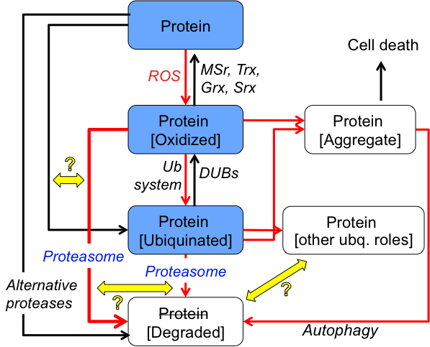
The challenge. Proteasomal degradation accounts for >90% of cellular protein turnover {Jung, 2009 #4580}, and failure to degrade oxidatively damaged proteins has detrimental effects for any cell, as the damaged proteins form toxic aggregates. Despite years of intense study, the exact role of ubiquitination for removal of these damaged proteins is the subject of an ongoing debate (Fig. 1.1). Protein poly-ubiquitination allows the cell to target proteins for degradation (and other processes) in a highly time-resolved and protein-specific manner {Hershko, 1998 #4744}, and there are several examples of ubiquitin-mediated degradation of oxidized proteins {Shang, 2001 #4772;Dudek, 2005 #4717;Medicherla, 2008 #4718;Lee, 2010 #4898}. However, ubiquitin-independent degradation of oxidatively damaged proteins has also been widely reported and has now been accepted as the predominant mechanism {Inai, 2002 #4680;Shringarpure, 2003 #1937;Asher, 2006 #4755;Kastle, 2011 #4565}. The two pathways are fundamentally different in their cost and result for the cell: ubiquitin-dependent degradation can be highly targeted and protein-specific, but requires strict regulation and cellular energy; in contrast, ubiquitin-independent degradation is comparatively simpler to regulate and does not require energy, but lacks specificity. The tight regulation of protein degradation is based on sequence and structure features of target proteins REFS, but our knowledge of these features is still largely incomplete as is our knowledge of the dependence. Truly understanding the relative importance of these degradation pathways requires a quantitative model with two key elements: (1) an integration of timing and strength of the proteome-wide effects of different pathways, and (2) a sequence/structure-specific model to predict the choice of degradation pathways.
The solution. We propose to combine large-scale quantitative proteomics techniques, controlled, time-resolved experiments, and computational modeling to resolve the choice of protein degradation pathways upon oxidative stress. We propose to identify and use a predictive of protein degradation. Producing a highly integrated data set from orthogonal large-scale experiments in the model system Saccharomyces cerevisiae, we will construct a comprehensive and quantitative model to predict ubiquitin-dependent and –independent degradation pathways after oxidative challenges based on sequence and structure features (Fig. 1.2). [Christine, I find a lot of this stuff repetitive.]

Aim 1. Determine priors of protein ubiquitination, oxidation, and degradation upon oxidative damage.
Using large-scale quantitative proteomics and inhibitors of translation, proteasomal degradation, and ubiquitination, we will characterize protein expression and modification changes for a large number of yeast proteins over a period of two hours. In this way we will isolate ubiquitination-dependent and -independent (as well as proteasome-dependent and -independent) changes in stability for several thousand proteins and monitor the dependence of these changes on oxidation and ubiquitination of the protein (and its peptides).

