Alan Siegel
______________________________________________________

Telling Lessons from the TIMSS Videotape:
Remarkable Teaching Practices as Recorded from Eighth-Grade Mathematics Classes
in Japan, Germany, and the U.S.

Why Another Study?
The outstanding performance of Japanese students on the Third International Math and Science Study (TIMSS) examinations, along with the accompanying TIMSS videotape classroom studies, have generated widespread interest in Japanese teaching practices. Unfortunately, despite this excitement, the majority of ensuing education analyses and policy reports seem to be based on incomplete portrayals of the actual teaching as documented on videotape. Part of the problem is that the teaching is remarkably rich. As a consequence, short summaries and even quotes from original sources sometimes fail to provide a balanced characterization of the actual lessons, and can even be just plain wrong.
These are strong words, and especially so if they happen to allege serious errors and misunderstandings in widely cited and highly respected studies. However, these works, despite being based on common sources of information, sometimes contradict each other, so some of the assertions cannot be right. On the other hand, it is only fair to point out that there are just a few such contradictions; most of the conclusions are consistent across all of the studies. But we also concur with the overall theme: the lessons as recorded in Japan are masterful. The main—and crucial—difference is in understanding the kind of teaching that made these lessons so remarkable.
For example, it is widely acknowledged that Japanese lessons often use very challenging problems as motivational focal points for the content being taught. According to the recent Glenn Commission Report,
In Japan, . . . closely supervised, collaborative work among students is the norm. Teachers begin by presenting students with a mathematics problem employing principles they have not yet learned. They then work alone or in small groups to devise a solution. After a few minutes, students are called on to present their answers; the whole class works through the problems and solutions, uncovering the related mathematical concepts and reasoning.
This study will resolve the crucial classroom question that the other reports left unanswered:
How in the world can Japanese eighth graders, with just a few minutes of thought, solve difficult problems employing principles they have not yet learned?

Background. The Third International Mathematics and Science Study comprises an enormously complex and comprehensive effort to assess primary and secondary school mathematics and science education worldwide. The examination phase began in 1995 with the testing of over 500,000 students in 41 countries and continued with repeat testing (TIMSS-R) in 1999, additional projects, and data analyses that are still a matter of ongoing research. As part of the TIMSS project, 231 eighth-grade mathematics lessons in Germany, Japan, and the U.S. were recorded on videotape during 1994–5. An analysis of these tapes, which includes a variety of statistics, findings, and assessments was reported in the highly influential TIMSS Videotape Classroom Study by James Stigler et al. This report also provides a detailed description of the Classroom Study’s data acquisition and analysis methodologies. Subsequently, James Stigler and James Hiebert published additional findings in The Teaching Gap, which emphasizes the cultural aspects of teaching and offers suggestions about how to improve teaching in the U.S.
In addition, the project produced a publicly available videotape containing excerpts from representative lessons in geometry and in algebra for each of the three countries, along with a discussion of preliminary findings narrated by Dr. Stigler. The excerpts of German and American lessons were produced in addition to the original 231 lessons, which are not in the public domain due to confidentiality agreements. For the Japanese lessons, disclosure permissions were obtained after the fact. The TIMSS videotape kit also includes a preliminary analysis of the taped lessons that follows the procedures used in the actual study. In addition, the TIMSS project produced a CD ROM with the same classroom excerpts.

What the Video Excerpts Show

The video excerpts, it turns out, provide indispensable insights that complement the more widely cited studies. They are the primary source for the following analysis, which compares the assessments and conclusions of the many studies against the actual classroom events as documented on tape.

Geometry. The tape shows the Japanese geometry lesson beginning with the teacher asking what was studied the previous day. After working to extract a somewhat meaningful answer from the class, he himself gives a summary: Any two triangles with a common base (such as AB in Figure 1) and with opposing vertices that lie on a line parallel to the base (such as the line through C, D, and P) have the same area because the lengths of their bases are equal, and their altitudes are equal.
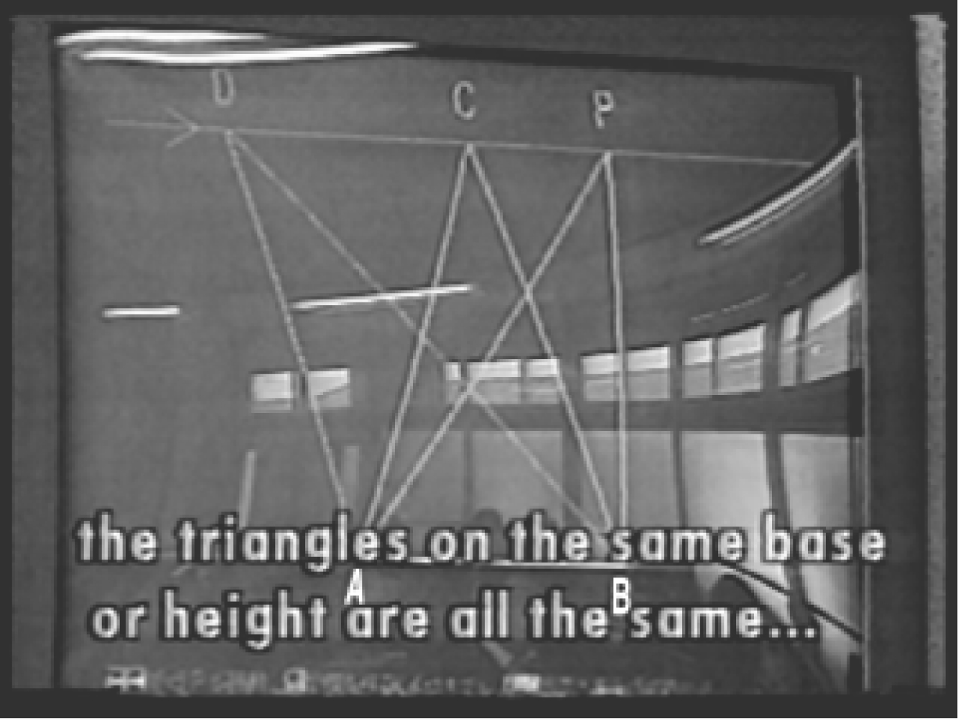
Figure 1 (letters A and B enhanced)
The teacher states this principle and uses his computer graphics system to demonstrate its potential application by moving vertex P along the line CD. The demonstration shows how to deform triangle ABP in a way that preserves its area. Next, he explains that this principle or method is to be the “foundation” for the forthcoming problem, which he then presents. It is the following.
Eda and Azusa each own a piece of land that lies between the same pair of lines. Their common boundary is formed by a bent line segment as shown.
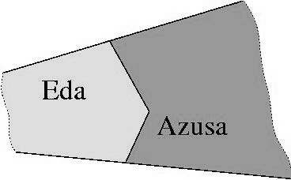Figure 2
The problem is to change the bent line into a straight line segment that still divides the region into two pieces, each with the same area as before.
Despite the previous review, the problem is still going to be a challenge for eighth graders, and it is fair to infer that the teacher understands this very well. In geometry, one of the most difficult challenges in a construction or proof is determining where to put the auxiliary lines. These lines are needed to construct the angles, parallel lines, triangle(s), etc. that must be present before a geometry theorem or principle can be applied to solve the problem. For the exercise in Figure 2, the key step is to draw two crucial auxiliary lines. One defines the base of a triangle that must be transformed in a way that preserves its area. The other is parallel to this base, and runs through its opposing vertex.
So what should a master instructor do? The answer is on the tape.
After explaining the problem, the teacher asks the students to estimate where the solution line should go, and playfully places his pointer in various positions that begin in obviously incorrect locations and progress toward more plausible replacements for the bent line. Now here is the point. With the exception of two positionings over a duration of about one second (which come shortly after the frame shown in Figure 4), none of his trial placements approximate either of the two answers that are the only solutions any student will find.
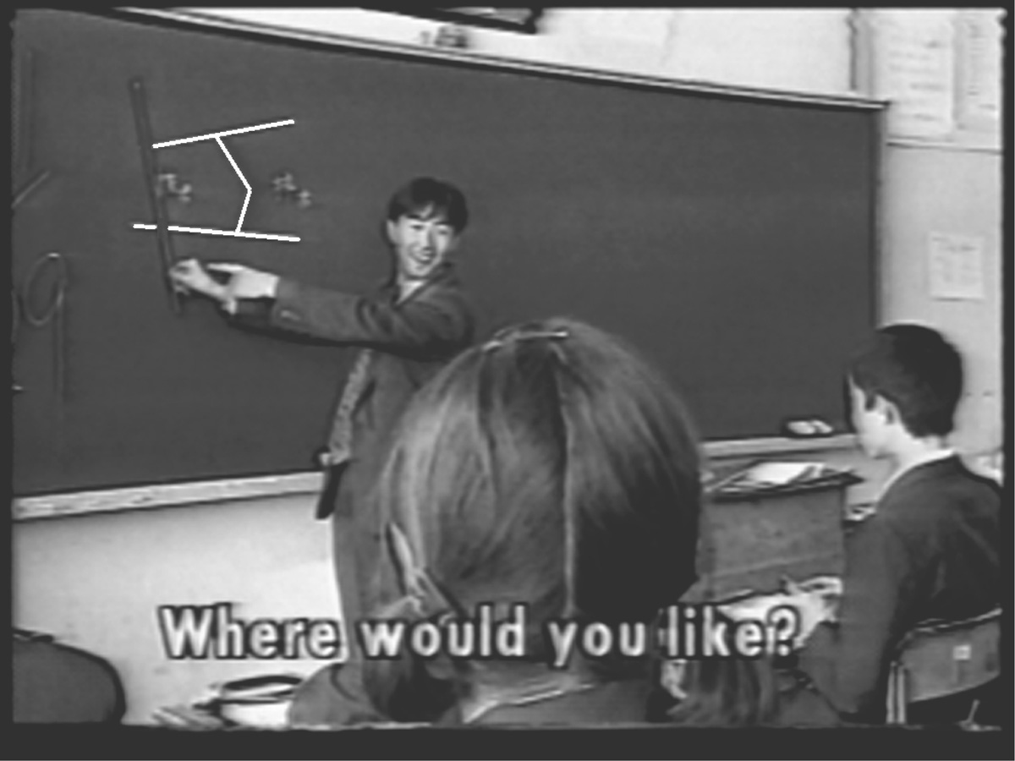
Figure 3 (digitally enhanced)
Rather, they are all suggestive of the orientation for the auxiliary lines that must be drawn before the basic method can be applied. He is giving subtle hints, and calling the students' attention to the very geometric features that must be noticed before the problem can to be solved. It is surely no accident that the teacher reaches two particular pointer placements more often than any other. One is shown Figure 4. The other is parallel to this placement, but located at the vertex that forms the bend in the boundary between Eda and Azusa.
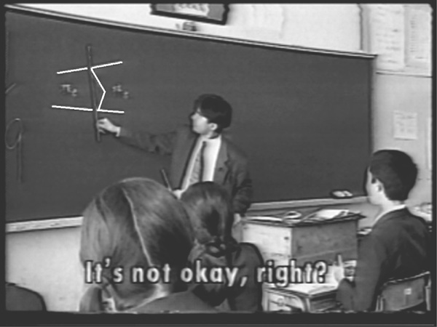Figure 4 (digitally enhanced)
Only after this telling warm-up—the heads-up review of the solution technique necessary to get the answer, and the seemingly casual discussion loaded with visual queues about what must be done—are the children allowed to tackle the problem.
But this is not the end of the lesson, and the students only get an announced and enforced three minutes to work individually in search of a solution.
As the children work, the teacher circulates among the students to provide hints, which are mostly in the form of leading questions such as: “Would you make this the base? [The question is] that somewhere there are parallel lines, ok?”
He then allocates an additional 3 minutes where those who have figured out the solution discuss it with the other teacher. Weaker students are allowed to work in groups or use previously prepared hint cards. The tape does not show what happens next. The TIMSS documentation reports that students prepare explanations on the board (9 minutes).
Then a student presents his solution. The construction is clearly correct, and he starts out with a correct explanation. However, when the time comes to find the solution, he gets lost and cannot see how to apply the area preserving transformation that solves the problem. The teacher then tells him to use “the red triangle” as the target destination.
The advice turns out to be insufficient, and the teacher steps in to redraw the triangle that solves the problem, and calls the student's attention to it with the words, “over here, over here.” The student seems to understand and begins the explanation afresh. But he soon winds up saying, “Well I don't know what I am saying, but . . ..” He then regains his confidence, and the presentation comes to an end. A number of students say that they do not understand. Then another student explains her answer, but the presentation is omitted from the tape. According to the Moderator's Guide, these two student presentations take altogether less than three minutes.
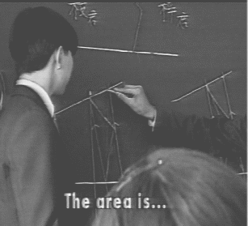
Figure 5
Next, the teacher explains how to solve the problem. There are two equivalent answers that correspond to moving vertex C, in the context of Figure 1 to the left or to the right. Both directions solve the problem, and he shows this. Such duality should not be surprising, since the word problem is not described in a way that, in the context of Figures 1, 6, and 7, can distinguish left from right. For completeness, we show the two ways that the triangle transformation technique can be used to solve the problem. In order to make the connection between the review material and the follow-up Eda-Azusa exercise absolutely clear, the solution with its two versions have been rotated to present the same perspective as in Figure 1, which introduced this triangle transformation technique.
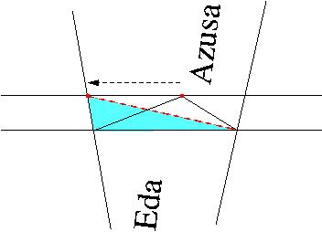
Figure 6
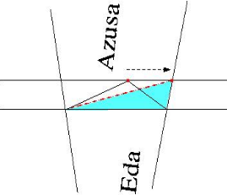
Figure 7
No one devised an alternative solution method.
The lesson continues with the teacher posing a new problem that can be solved with the same technique. This time the figure is a quadrilateral, and the exercise is to transform it into a triangle with the same area. At this point, the basic solution method should be evident, since the previous problem, as the teacher pointed out, also concerned the elimination or straightening of a corner in an area preserving way. However, added difficulty comes from the need to recognize that two consecutive sides of the quadrilateral should be viewed as representing the bent line of Figure 2. Notice, by the way, that if each of the other two neighboring sides is extended as an auxiliary line, then the resulting figure is changed into a version of the Eda-Azusa problem. (See Figure 9.) Evidently, this exercise is very well chosen.
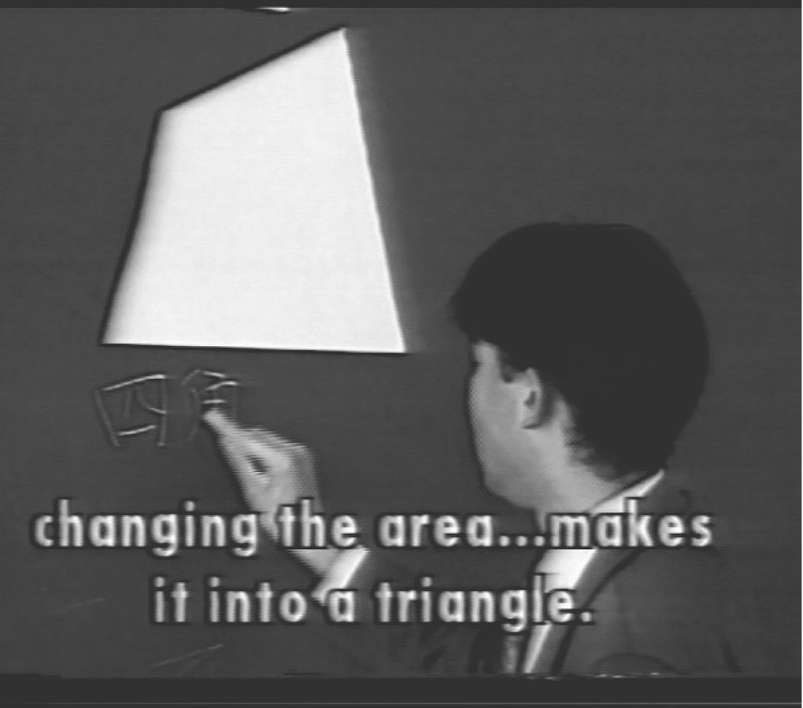Figure 8
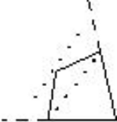Figure 9
The basic line straightening method can be applied so that any one of the four vertices can serve as the point where the line bends, and this designated vertex can be shifted in either of two directions to merge one of its two connecting sides with one of the auxiliary lines. The students again work individually for three minutes, and then are allowed to work in groups, use hint cards or ask the teacher.
The TIMSS documentation indicates that this joint phase lasts for 20 minutes, and includes students presenting their answers. There are apparently eight such presentations, which were selected to illustrate all eight ways the basic method can be applied: there are four vertices that each can be moved two ways. Then the teacher analyzes these eight ways in greater depth, and explains how they all use the same idea. All students remain seated during this portion of the lesson, and he controls the discussion very carefully and does almost all of the speaking.
An Analysis of the Teaching and its Content. This lesson is nothing less than a masterpiece of teaching, and the management of classroom time was remarkable. While many students did not solve the first problem of the day, the assignment certainly succeeded in engaging the attention of everyone. The second problem was no give-away, but it gave students the chance to walk in the teacher's footsteps by applying the same ideas to turn a quadrilateral into a triangle. The teacher-led study of all possible solutions masked direct instruction and repetitive practice in an interesting and enlightening problem space.
Evidently, no student ever developed a new mathematical method or principle that differed from the technique introduced at the beginning of the lesson. Altogether, the teacher showed how to apply the method 10 times. Yet the lesson is an excellent example of how to teach problem solving, because each successive problem required an ever deeper understanding of the basic proof technique. For homework, the teacher asked the students to transform a five-sided polygon into a triangle with the same area.
Notice that this lovely problem variation hints at the use of induction: the way to solve it is to transform a five-sided figure into a quadrilateral, which can then be transformed into a triangle. The basic corner elimination scheme can now be seen to work for any (convex) polygon, so that any such n-sided polygon can be transformed into one with n – 1 sides and the same area, for n > 3.
It is also worth pointing out that the solution technique, which is a specific application of measure preserving transformations, has additional uses. It appears, for example, in Euclid's proof of the Pythagorean Theorem (cf. Book I Prop 47 of Euclid's Elements). More advanced exercises of this type appear on national middle school mathematics competitions in China and regional high school entrance examinations in Japan. And it is not much of a stretch to suggest that measure preserving transformations lie at the heart of those mysterious changes of variables in the study of integral calculus. All in all, the lesson is a wonderful example of the importance of a deep understanding of mathematics and its more difficult aspects.

Algebra. The Japanese algebra lesson begins with student-presented answers for each of the previous day's six homework problems. These activities, along with the accompanying classroom discussion are omitted from the excerpts.
Then the teacher presents a more challenging problem that uses the same basic calculation method that the students have been studying, but needs one common sense extension. The problem is this.
There are two kinds of cake for sale. They must be bought in integer multiples; you cannot buy a fraction of a cake. The most delicious cake costs 230 yen, and a less tasty one is available for 200 yen. You wish to purchase 10 cakes but only have 2,100 yen. The problem is to buy 10 cakes and have as many of the expensive cakes as possible while spending no more than 2,100 yen.
It is clear that the students had already studied versions of the problem that would permit fractional units of cakes to be purchased. The reproduction of the six homework exercises as shown in the TIMSS Moderator's Guide confirms that the class was already experienced with the technical mechanics necessary to solve problems with inequalities. It is also evident that they had been studying word problems and the translation of word problems into equations and inequalities that can then be solved. Indeed, the teacher introduces the problem with the remarks, “Today will be the final part of the sentence problems.” Thus, it is fair to infer that the only difference between the cake problem and the material they had just reviewed is the requirement that the solution must comprise integer multiples of each cake.
After making sure that the students understand the problem, he asks them to devise a way to solve it. They get an announced and enforced three minutes.
Next, the teacher solicits solution approaches from the students. A student volunteers that she tried all possibilities. Her approach was to try 10 cheap cakes, then 9 cheap ones and 1 expensive one, etc., until she had the best answer. However, she was unable to finish in the three minutes that the teacher allocated for the problem. The teacher emphasizes the point, and it will soon become clear that part of the lesson is to show that this unstructured approach is unsound.
He then briefly discusses another way to solve the problem. The approach, which is quite inventive, uses a notion of marginal cost. If we buy 10 of the most expensive cakes, we exceed our budget by 200 yen. Trading in an expensive cake for a cheaper cake gives a net savings of 30 yen. Obviously, seven cakes have to be traded in, which shows that the answer is 3 expensive cakes and 7 cheaper ones. As the teacher expected, no student solved the problem this way.
Then he calls on another student, who explains how she set up the problem as an inequality, solved it as an equality, and then rounded the number of expensive cakes down to the nearest lesser integer. As she explains the equation, he writes it on the board. Only a few students understand the explanation, and he asks for another explanation of the same process. In subsequent activities that are only summarized on the tape and in the Moderator's Guide, the teacher then passes out a worksheet and works through a detailed analysis of the solution for the class.
After the detailed presentation, another problem of the same type was assigned, but with larger numbers. The teacher's words are telling:
If you count one by one, you will be in an incredibly terrible situation. In the same way that we just did the cake situation, set up an inequality equation by yourself and find out . . .[the answer]. Because finding the answers one by one is hard, I wonder if you see the numerous good points of setting up inequality equations . . ..
The students work on the problem individually. After 11 minutes, the teacher went over the problem with the class. The video excerpts contain no group-based problem solving in this algebra lesson, and the Moderator's Guide confirms that none of the class time included problem solving in groups.
Each class ended with the teacher summarizing the solution technique that constituted the lesson of the day.
An Analysis of the Teaching and its Content. Students never developed new solution methods. In the algebra class, the students were given the opportunity to learn first-hand why amorphous trial-and-error approaches (which seem to be encouraged by some of the latest reform programs) do not work. While the tape does not explicitly show how many students were able to solve the original cake problem in the allotted time, the student responses suggest that no more than 4 or 5 could have possibly succeeded. But the three minutes of struggle might well have served to make the lesson more purposeful.
From a mathematical perspective, the cake problem was designed to require a deep understanding of inequality problems and their solution. Mathematicians would say that when we solve a problem, we find all of the answers. If the cake problem had allowed fractional purchases, and had simply required that altogether any mix of ten cakes be purchased for at most 2100 yen, then the algebraic formulation would read:
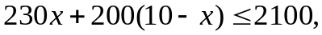
where x is the number of expensive cakes purchased, and 10 – x is the number of the inexpensive ones. The problem would also require that x be non-negative, since you cannot buy negative quantities of cake. A little algebraic manipulation gives the solution as the interval
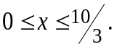
Now, every x in this interval is a solution to the simplified problem, and every solution to the problem is in this interval. So if we want a special answer, the interval [0, 10/3] is the place to look. If we want the largest x, it is 10/3. If we want the largest integer x, it is 3. And if we wanted the largest even integer, for example, we would look nowhere else than into [0, 10/3] to conclude that this answer is x = 2. Incidentally, a complete answer must also observe that the number of inexpensive items is non-negative (which is to say that x ≤ 10).
So this problem variant is more than a matter of common sense; it exposes students to a deep understanding of solutions to inequalities and the implications of real world constraints. Moreover, the problem illustrates the idea of decomposing a complex exercise into a more basic problem whose solution can then be adapted to achieve the original objective.
In summary, the video excerpts feature challenge problems that cover fundamental principles, techniques, and methods of systematic thought that lie at the heart of mathematics and problem solving. As such, they ought to provide experiences that build a powerful foundation of intuition and understanding for more advanced material yet to come. As a derivative benefit, these problems are so rich they can be readily transformed into follow-up exercises for use as reinforcement problems in class and as homework.

Defining Terms: Discovery and Invented Methods
Many publications claim that the Japanese lessons teach students to invent solutions, develop methods, and discover new principles. For example, this view is expressed in the Glenn Commission report, and is endorsed by the Video Study as well: “[In Japan, the] problem . . . comes first [and] . . . the student has . . . to invent his or her own solutions.” In fact, the Study reports that the 50 Japanese lessons averaged 1.7 student-presented alternative solution methods per class. Yet the excerpts exhibit no signs of such activity. They contain just one student-devised solution alternative, and it failed to produce an answer.
These differences are fundamental, and they should be reconciled. Part of the problem is that students are unlikely to devise their own solutions when the time is limited, the problems are so difficult that hints are needed, and the exercises are (clearly) designed to teach the value and use of specific techniques. Students would presumably have a better chance of finding alternative solution methods for less challenging exercises. And they would have an even better chance with problems that can be solved by a variety of methods that have already been taught. Examples might include geometry problems where different basic theorems can be used, and studies of auxiliary lines where the exercises are designed so that different auxiliary lines build different structures that have already been studied. The Videotape Study illustrates alternative solution methods with the U.S. assignment to solve x² + 43x – 43 = 0 by completing the square and by applying the quadratic formula. Of course, this problem directed students to use different methods they already knew. The example contains no hint of any discovery.
So the question remains: where are the alternative solution methods, and when do they demonstrate signs of student-discovery?
The answers are in the Video Study. It presents actual examples that were used to train the data analysts who counted the “Student Generated Alternative Solution Methods” (SGSM1, SGSM2, . . .) in each lesson. These examples, it turns out, come from the geometry lesson in the video excerpts: the two student presentations for the Eda-Azusa problem are coded as SGSM1 and SGSM2. Similarly, the second problem, where each of four vertices could be moved in two directions, has the codings SGSM1–SGSM8. Altogether, this lesson is counted as having ten student-generated alternative solution methods, even though it contains no student-discovered methods whatsoever. And the failed try-all-possibilities approach in algebra excerpts is counted as yet another student-discovered solution method.
The Videotape Study also contains a partial explanation for the source of these judgments. It reports that the data coding and interpretation procedures were developed by four doctoral students—none of whom were in mathematics programs. Moreover, the Study states that the project's supporting mathematicians only saw coder-generated lesson tables, and were denied access to the actual tapes. It seems reasonable to infer, therefore, that they did not participate in the design of these coding practices. As for the question of invention, the Video Study explains: “When seatwork is followed by students sharing alternative solution methods, this generally indicates that students were to invent their own solutions to the problem.” Altogether, there appears to have been a sequence of interpretations based on very generous counting of student presentations as student-generated alternative solution methods, as invented, and ultimately as some kind of invented discoveries that might even depend on new principles the students had not yet learned.
On the other hand, the contributions by the Japanese teachers received much less generous recognition. Yet in the defining examples of student discovery, the teachers—not the students—manage the ideas and lead the education process.

Additional Statistics from the TIMSS Projects
It is worth reiterating that in the Japanese lesson excerpts, each of the four exercises began with students working individually to solve the problem. Similarly, the Stigler-Hiebert analysis states, “Students rarely work in small groups to solve problems until they have worked first by themselves.” The detailed TIMSS Videotape Classroom Study contains no comparable statement, and even implies otherwise: “[After the problem is posed, the Japanese] students are then asked to work on the problem . . . sometimes individually and sometimes in groups.” However, not one of its 86 figures and bar charts documents instances where problems began with students working in groups. Chart 41 indicates that of the seatwork time spent on problem solving, 67.2% of the time comprised individual effort and 32.8% of the time was spent in group work.
Another TIMSS study addressed this issue by collecting statistics for carefully balanced samples of eighth graders. For each country, the sample base comprised approximately 4000 students. Their teachers were queried about their classroom organizations and whether most of the lessons had students working in small groups, individually, and/or as a class. Teachers were also asked if they assisted students in the classroom assignments. The results, which were weighted by the number of students in each responding teacher’s class, are reproduced below for the U.S. and Japan.
The table shows that Japanese lessons do not have significant numbers of small-group activities. In fact, American classes evidently contain 4 to 6 times as many such lessons. Of course, it should be noted that the data is based on questionnaires and depends, therefore, on the judgment of each respondent. The meaning of “most or every lesson” might have cultural biases, as might the definitions of “small groups” and “teacher assistance.” Still, these TIMSS statistics support the notion that the Japanese style of teaching is substantially different from many of the U.S. reform practices.
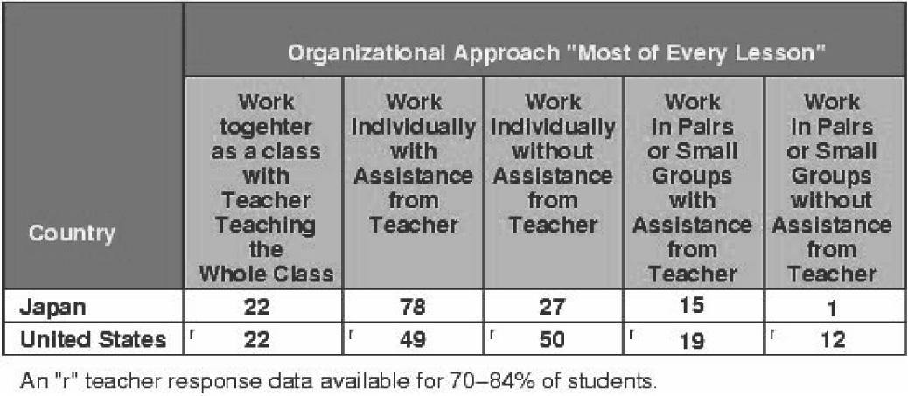Figure 10 (extracted from Beaton et al., pp. 154-5)

The Matter of Pedagogy
One such reform approach relies on discovery-based learning, which aims to have the students themselves discover mathematical principles and techniques. At first blush, the idea of discovery-based learning seems attractive. After all, we are more likely to recall what we discover for ourselves, and even if we forget such a fact, we should be able to rediscover it at a later date. According to Cobb et al,
It is possible for students to construct for themselves the mathematical practices that, historically, took several thousand years to evolve.
However, as with any idealized theory, the real issues are in the implementation practices.
- Judgments must assess how much time is needed for students to discover the mathematics, and the necessary tradeoffs among time for guided discovery, time for additional (or deeper) lessons, and time for practice.
- There must be detection and correction mechanisms for incorrect and incomplete “discoveries.”
- There must be allowances for the fact that in even the best of circumstances, only a handful of students have any likelihood of discovering non-trivial mathematical principles.
The videotaped lessons from Japan show fundamental decisions that are startling, and very different from the reform practices in the U.S. In the Japanese classes, the time allotted for the first round of grappling with problems was remarkably modest. Consequently, the remaining time was sufficient for student presentations to help identify conceptual weaknesses, teacher-managed assistance and summations, as well as for follow-up problems designed to solidify understanding. However, due to the time limitations and the difficulty of the problems, most students were learning via a model of “grappling and telling.” That is, students would typically struggle with a tough problem in class, but not find a solution. They would then learn by being told how to solve it, and would benefit from the opportunity to contrast unsuccessful approaches against methods that work. There is no question that preliminarily grappling with a problem is both motivational and educational. Similarly, discussion about why some approaches fail and why a solution might be incomplete, along with the exploration of alternative problem solving techniques are all highly beneficial investments of time. But the use of grappling and telling creates yet another implementation issue, which is:
Who should do the telling?
In some teaching practices, the theory of discovery-based learning is extended to include the notion of cooperative learning, which holds that the students should teach one another because they “understand” each other. However, both the TIMSS videotape and the data in Figure 10 show that Japanese teaching is by no means purely or principally based on cooperative learning. While students get a substantial amount of time to explain their solutions, the video excerpts show that Japanese teachers are by no means passive participants. Student explanations frequently need—and get—supervision, and students can be remarkably incoherent (cf. Figure 5) even when their solutions are absolutely perfect. When all is said and done, the teachers do the teaching—and the most important telling—but in an interactive style that is highly engaging and remarkably skillful.
According to Stigler and Hiebert, some lessons feature considerably more direct instruction or extended demonstrations, while yet others demand that the students memorize basic facts. Students might even be asked to memorize a mandate to think logically. Evidently, the lessons do not follow a rigid pattern. If any theme is common to these approaches, perhaps it is that while the lessons vary depending on the nature of the mathematical content, they always engage the students in an effort to foster thinking and understanding.
Placing Japanese Teaching in the Context of U.S. Reform. The video excerpts show Japanese lessons with a far richer content than the corresponding offerings from the U.S. and Germany. According to the Video Study, the Japanese, German, and U.S. eighth-grade classes covered material at the respective grade levels 9.1, 8.7, and 7.4 by international standards. Evidently, the interactive nature of the Japanese teaching style and the use of challenging problems are managed so well that the content was actually enhanced. We believe that a key reason for this high performance level is the efficient use of grappling and telling coupled with the benefits of disguised reinforcement exercises.
Additional analysis shows that 53% of the Japanese lessons used proof-based reasoning, whereas the comparable statistic for the U.S. lessons—which included both traditional and reform programs—stood at zero. And in terms of the development of concepts, their depth and applicability, as well as in terms of the coherence of the material, the quality assessments were much the same. By all evidence, the use of proof-based reasoning as reported in Japan is not at all representative of the reform programs in the U.S., and the use of such remarkably challenging problems seems beyond the scope of any American program past or present.
When comparing U.S. reform practices and Japanese teaching methods, the Video Study offers somewhat guarded conclusions that are sometimes difficult to interpret. The report reads:
Japanese teachers, in certain respects, come closer to implementing the spirit of current ideas advanced by U.S. reformers than do U.S. teachers. For example, Japanese lessons include high-level mathematics, a clear focus on thinking and problem solving, and an emphasis on students deriving alternative solution methods and explaining their thinking. In other respects, though, Japanese lessons do not follow such reform guidelines. They include more lecturing and demonstration than even the more traditional U.S. lessons [—a practice frowned upon by reformers], and [contrary to specific recommendations made in the NCTM Professional Standards for Teaching Mathematics,] we never observed calculators being used in a Japanese classroom.
Subsequent elaboration on the similarities between U.S. reform and Japanese pedagogy recapitulates these ideas in the context of various reform goals, but again offers no statistical evidence to compare with the data accumulated from the analysis of Japanese teaching practices. Consequently, it is difficult—absent additional context—to compare these reform notions in terms of mathematical coherence, depth, international grade level, or the preparation of students for more advanced studies and challenging problems. Not surprisingly, “the spirit of current reform ideas” seems difficult to measure. Similarly, the Japanese and U.S. reform pedagogies appear incomparable in their management of classroom time, their use of proof-based reasoning, their tradeoffs between student-discovery and the use of grappling and telling, as well as their use of individual and small group activities.
These distinctions not withstanding, the notion that Japanese teaching might be comparable to U.S. reforms is given even greater emphasis in a major Government report, which flatly declares:
Japanese teachers widely practice what the U.S. mathematics reform recommends, while U.S. teachers do so infrequently.
This report on best teaching practices worldwide makes no mention of any differences between the U.S. reforms and Japanese teaching styles. Evidently, its perspective differs from that of its source of primary information, which is the more cautiously worded TIMSS Videotape Study. Moreover, even the differences identified in the Video Study—which concern direct instruction, calculators, and teacher-managed demonstrations—are all matters of contention in the U.S. debate over classroom reform.
Lastly, it is significant (but seldom reported) that the Video Study makes a distinction between the idealized goals as prescribed in the NCTM Professional Standards for Teaching Mathematics, and as embodied in actual classroom practices of some reform programs. In particular, the Study discusses two reform-style lessons. One comprises the playing of a game that is purported by the teacher as being NCTM compliant, but happens to be devoid of mathematical content: “It is clear to us that the features this teacher uses to define high quality instruction can occur in the absence of deep mathematical engagement on the part of the students.” The other lesson was deemed to be compliant with the spirit of NCTM reforms. It began with the teacher whirling an airplane around on a string. The class then spent the period in groups exploring how to determine the speed of the plane, and coming to realize that the key issues were the number of revolutions per second, and the circumference of the plane's circular trajectory. The homework was a writing assignment: the students were asked to summarize their group's approach, and to write about the role they played in the group's work. The Study did not evaluate the content by grade level, nor compare the lesson against the qualities that seem representative of Japanese teaching practices.
The Video Study reported that there was, apart from some minor differences, “little quantitative evidence that reform teachers in the United States differ much from those who claim not to be reformers. Most of the comparisons were not significant.” However, it is not evident how effective the Study's comparison categories were at quantifying the key differences in various teaching practices.
Other Characterizations of Japanese Classroom Practices. Studies that use human interaction as a primary source of data must rely on large numbers of interpretations to transform raw, complex, occasionally ambiguous, and even seemingly inconsistent behavior into meaningful evidence. Given the complexity of the lessons, it is not surprising that different interpretations should arise. The Video Tape Study—to its credit—documents an overview of these decision procedures, although their specific applications were far too numerous to publish in detail. Moreover, the Study actually contains a wide diversity of observations, ideas, and conclusions, which sometimes get just occasional mention, and are necessarily excluded from the Executive Summary. Understandably, this commentary is also missing—along with any supporting context—from the one-sentence to one-paragraph condensations in derivative policy papers. Perhaps the seventh and eighth words in the opening line of the Study's Executive Summary explain this issue as succinctly as possible: “preliminary findings.” It is now appropriate to explore these larger-picture observations and to place them within the context of actual lessons.
The Study even offers a couple of sentences that support our own observations:
[Japanese] students are given support and direction through the class discussion of the problem when it is posed (figure 50), through the summary explanations by the teacher (figure 47) after methods have been presented, through comments by the teacher that connect the current task with what students have studied in previous lessons or earlier in the same lesson (figure 80), and through the availability of a variety of mathematical materials and tools (figure 53).
Unfortunately, these insights are located far from the referenced figures and the explanations that accompany them. The words are effectively lost among the suggestions to the contrary that dominate the report. It is also fair to suggest that the wording and context are too vague to offer any inkling of how powerful the “support and direction through class discussion” really was, and likewise the value of the connections to previous lessons is left unexplored. This discussion does not even reveal if these connections were made before students were assigned to work on the challenge problems, or after. For these questions, the video excerpts provide resounding answers: the students received masterful instruction.
The Videotape Study’s Math Content Group analyzed thirty classroom lesson tables that were selected to be representative of the curriculum. Their assessments, as sampled in the Video Study, agree with our overall observations, apart from the use of hints, which were mostly omitted from the lesson tables. Unfortunately, the analyses are highly stylized with abstract representations for use in statistical processing and were, presumably, not intended to be a reference for the actual teaching.
Another sentence in the Study begins with the potentially enlightening observation that:
The teacher takes an active role in posing problems and helping students examine the advantages of different solution methods, [however, rather than elaborating on how this takes place, the sentence changes direction with the words] but the students are expected to struggle with the mathematical problems and invent their own methods.
This interpretation of student work as inventive discovery appears throughout the TIMSS Videotape Study. In its analysis of the excerpted Japanese geometry lesson, the Video Study categorizes the teacher's review of the basic solution method (shown in Figure 1) as “Applying Concepts In New Situation,” but inexplicably switches tracks to count the student applications as invented student generated alternative solution methods. Another such instance reads, “students will struggle because they have not already acquired a procedure to solve the problem.” Similarly, the Study never explains how teachers participate in the problem solving by teaching the use of methods and by supplying hints. Its only discussion about hinting is to acknowledge the offer of previously prepared hint cards. And by the time the Glenn Commission finished its brief encapsulation of student progress, even the struggle had disappeared along with proper mention of extensive teacher-based assistance.

Searching for Answers
Let there be no doubt: the fact that we found no evidence of widespread inventiveness or student discovery should not be interpreted as a condemnation of student-exploration. Rather, it suggests a need for balance based on a realistic recognition of what can and cannot be done in classrooms.
Creativity and independent mathematical thought should be fostered, and alternative solution methods should be encouraged and studied. Students need to know that problems can be solved in different ways. They should learn to step back from a problem and think about plausible solution methods. And they need experience selecting the best strategies for plans of first attack. Similarly, students should learn first-hand how problems are adapted to fit the method, and how methods can accommodate new problems.
The Japanese lessons illustrate master instruction designed to foster this higher-level reasoning. When combined with modeling, these activities comprise the essence of problem solving.
However, despite the wealth of hints, the careful reviews of the necessary material and the presumptive benefits accumulated from years of exposure to these teaching practices, the students discovered no new principles, theorems, or solution methods. And despite extensive assistance, many students did not conquer the first challenge problem of the day. These are sobering facts, and their implications for mathematics education should not be overlooked.
Just imagine: if the application of principles already learned and just reviewed is so difficult, consider how hard it must be to devise new principles. Ask mathematicians what they can do with three minutes of original thought. Chances are your answer will be no more than a quizzical look. New principles do not come cheap; research mathematics—even when there is strong evidence to suggest what might be true—requires enormous amounts of time. And eighth graders will find the concepts and principles underlying eight-grade level math just about as difficult to develop. In short, there is a fundamental difference between problem solving and developing new principles. There are world-class mathematicians who are mediocre problem solvers, and vice-versa. Very few mathematical researchers would ever confuse the art of problem solving with the development of new mathematics. The implications for K-12 education and mathematics pedagogy are clear. Before we can understand what teachers and students should be doing in daily lessons, we must have a deep understanding of what they are doing as well as what they can and cannot do. These distinctions—profound but sometimes subtle—lie at the heart of why modern mathematics developed over a period of two centuries or so, and why arithmetic and elementary mathematics took even longer.

Conclusions
Large-scale video studies must rely on data coding and all kinds of preliminary judgments and filterings to encapsulate raw data. To cut through these sources of potential information loss and possible confusion, this study did something that the others did not. We supported our observations with a combination of the actual video images, a meticulous analysis of the mathematics lessons, and detailed citations together with a careful presentation of the context for each reference. Similarly, we sought to include relevant information regardless of whether or not it supported our conclusions. And whenever inconsistencies surfaced, we endeavored to reconcile the differences.
Of course, we must avoid extrapolating from a few “representative” tapings to draw conclusions about a much larger set of lessons, much less the national characteristics of classroom teaching in the U.S., Germany, and Japan. But with 229 lessons unavailable, and just six representative classes in view, there is little choice but to analyze the evidence that is in the public domain. Accordingly, this study should be viewed as a cautionary warning about widely cited opinions that might in fact be erroneous.
In summary:
- The videotapes of Japanese lessons document the teaching of mathematical content that is deep and rich.
- The excerpts do not support the suggestion that in Japan, “[The] problem . . . comes first [and] . . . the student has . . . to invent his or her own solutions.”
- The evidence does suggest that in Japan, “Students rarely work in small groups to solve problems until they have worked first by themselves.”
- Similarly, the evidence gives little weight to the notion that “Japanese teachers, in certain respects, come closer to implementing the spirit of current ideas advanced by U.S. reformers than do U.S. teachers.”
- The evidence does confirm that, “In other respects, Japanese lessons do not follow such reform guidelines. They include more lecturing and demonstration than even the more traditional U.S. lessons . . ..”
- The excerpts show Japanese classes featuring a finely timed series of mini-lessons that alternate between grappling-motivated instruction on how to apply solution methods, and well chosen challenge exercises designed to instill a deep understanding of the solution methods just reviewed. No other interpretation is possible.
- Some official U.S. Government reports overemphasize unsubstantiated claims about Japanese pedagogy, while omitting all mention of the remarkably high quality instruction that is characteristic of Japanese lessons.
- Studies of problem solving in the classroom should include statistical analyses of as large a variety of practices and interactions as possible, including the use of grappling and telling, in-progress hints and mentoring, and preparatory discussion with hints and applicable content. Similarly, the roles of teacher assistance in presentations of all kinds ought to be better understood.
- Research projects in mathematics education should strive to maintain open data to support independent analyses. In addition, great care should be exercised to ensure that the codings and analyses incur no loss of mathematical content or pedagogy.
It is perhaps fitting to close with a few words that strip away the citations, figures, tables, and video images that characterize the preceding analysis, and to express some observations in more human terms.
Everyone understands that students must learn how to reason mathematically. The heart of the matter, therefore, is how —not whether—to teach problem solving and mathematical investigation. We must not be so desperate for the teaching of problem solving that we acclaim all such efforts to be one and the same and, therefore, equally promising. The video excerpts document exemplary instances of master teachers instructing students in the art of adapting fundamental principles to solve problems. In each sample excerpt, the class had already learned the basic method necessary to solve the challenge problems of the day. However, students had to possess a very solid understanding of the method before it could be applied successfully.
This form of teaching requires a deep understanding of the underlying mathematics and its difficulty. Students must be properly prepared so that they can master the content at an adequate pace. Whenever hints are necessary, the teacher must be sensitive to these needs and stand ready to offer whatever assistance is appropriate to open the eyes of each individual learner. More often than not, most students will be unable to apply fundamental principles in new settings until they see step-by-step examples completed by the teacher. In these cases, the students should then get the opportunity to walk in the teacher's footsteps by applying the approach to a new problem that is designed to have the same challenges in a slightly different context.
These are the lessons that must be learned from the videotape of Japanese teaching. As the excerpts demonstrate, a master teacher can even present every step of a solution without divulging the answer, and can, by so doing, help students learn to think deeply. In such circumstances, the notion that students might have discovered the ideas on their own becomes an enticing mix of illusion intertwined with threads of truth. Unfortunately, such misunderstanding risks serious consequences if it escalates to a level that influences classroom practice and education policy. In retrospect, it seems appropriate to offer one last cautionary recommendation. Unless lesson studies include a comprehensive analysis of the mathematics content and the full range of teaching techniques, their conclusions will perforce be incomplete and, as a consequence, vulnerable to misconceptions about the very practices that best enhance student learning.
Acknowledgments. It is a pleasure to thank Clilly Castiglia and Kevin Feeley of the NYU Center for Advanced Technology and the Media Research Lab, who graciously provided the VHS frame processing. The author would also like to thank Professor Michiko Kosaka for resolving several questions about the actual Japanese as recorded in the excerpts.

References
Beaton, A. E. et al. Mathematics Achievement in the Middle School Years: IEA's Third International Mathematics and Science Report. TIMSS International Study Center (ISC), Boston College, 1996. http://timss.bc.edu/TIMSS1/MathB.html.
Bransford, J. D. et al. How People Learn: Brain, Mind, Experience and School. National Research Council, National Academy Press, 2000. http://stills.nap.edu/readingroom/books/hpl.
Cobb, P., E. Yackel, and T. Wood. “A constructivist alternative to the representational view of mind in mathematics education.” Journal for Research in Mathematics Education 23 (1992): 2–33.
Glenn, J. et al. Before It's Too Late, A report to the Nation from the National Commission on Mathematics and Science Teaching for the 21st Century. Report EE0449P, Education Publications Center, U.S. Department of Education, Sept. 27, 2000. http://www.ed.gov/americacounts/glenn/.
Martin, M.O. et al. School Contexts for Learning and Instruction, IEA's Third International Mathematics and Science Study. TIMSS ISC, Boston College, 1999. http://timss.bc.edu/timss1995i/TIMSSPDF/SRWhole.pdf.
Mullis, I.V.S. et al. TIMSS 1999 International Mathematics Report, Findings from the IEA's Repeat of the Third International Mathematics and Science Study at the Eighth Grade. TIMSS ISC, Boston College, Dec., 2000. http://timss.bc.edu/timss1999i/math_achievement_report.html.
Peak, L. et al. Pursuing Excellence: A Study of U. S. Eighth-Grade Mathematics and Science Teaching, Learning, Curriculum, and Achievement in International Context. NCES 97-198, National Center for Education Statistics (NCES), 1996. http://.nces.ed.gov/pubs97/97198.pdf.
Schwartz, D.L., and J.D. Bransford. A time for telling, Cognition and Instruction 16 (1998): 475–522.
Stigler, J.W. and J. Hiebert. The Teaching Gap: Best Ideas from the World's Teachers for Improving Education in the Classroom. Free Press, 1999.
Stigler, J.W. et al. The TIMSS Videotape Classroom Study: Methods and Findings from an Exploratory Research Project on Eighth-Grade Mathematics Instruction in Germany, Japan, and the United States. Report NCES 99-074, NCES, 1999. http://nces.ed.gov/pubs99/1999074.pdf.
Eighth-Grade Mathematics Lessons: United States, Japan, and Germany. Videotape, ORAD 97-1023, U.S. Dept. of Education, Office of Educational Research and Improvement, TIMSS Project, GPO Stock order # 065-000-01016-0, NCES, 1997.
Moderator's Guide to Eighth-Grade Mathematics Lessons: United States, Japan, and Germany. U.S. Dept. of Education, Office of Educational Research and Improvement, TIMSS Project, NCES, 1997. http://www.enc.org/topics/timss/kit/documents/0,1946,ACQ-125445-5445_toc,00.shtm.
Video Examples from the TIMSS Videotape Classroom Study: Eighth Grade Mathematics in Germany, Japan, and the United States. CD ROM, U.S. Dept. of Education, Office of Educational Research and Improvement, TIMSS Project NCES 98-092, GPO Stock order # 065-000-01137-9, NCES, 1998. http://nces.ed.gov/spider/webspider/98092.shtml.

. Cf. J. W. Stigler et al., The TIMSS Videotape Classroom Study: Methods and Findings from an Exploratory Research Project on Eighth-Grade Mathematics Instruction in Germany, Japan, and the United States (National Center for Education Statistics (NCES) 1999), p. 134.
. J. Glenn et al., Before It's Too Late, A report to the Nation from the National Commission on Mathematics and Science Teaching for the 21st Century the 21st Century, Report EE0449P, Education Publications Center, U.S. Department of Education, (Sept. 27, 2000), p. 16.
. M.O. Martin et al., School Contexts for Learning and Instruction IEA’s Third International Mathematics and Science Study (TIMSS International Study Center (ISC), 1999).
. I.V.S. Mullis et al., TIMSS 1999 International Mathematics Report, Findings from the IEA’s Repeat of the Third International Mathematics and Science Study at the Eighth Grade (TIMSS ISC, Dec., 2000).
. J. W. Stigler et al., “TIMSS Videotape Classroom Study.”
. J. W. Stigler and J. Hiebert, The Teaching Gap: Best Ideas from the World's Teachers for Improving Education in the Classroom (Free Press, 1999).
. Eighth-Grade Mathematics Lessons: United States, Japan, and Germany (Videotape, NCES, 1997).
. Moderator's Guide to Eighth-Grade Mathematics Lessons: United States, Japan, and Germany (NCES, 1997).
. Video Examples from the TIMSS Videotape Classroom Study: Eighth Grade Mathematics in Germany, Japan, and the United States (CD ROM, NCES, 1998).
. In Figure 1, the translation shows an “or” instead of an “and.” This mathematical error is due to a mistranslation of the spoken Japanese.
. “Moderator’s Guide,” p. 136.
. Ibid., p. 140.
. Ibid.
. Ibid., pp. 139–41.
. Ibid., p. 141.
. The assignment probably should be restricted to convex figures; otherwise it includes irregular cases that are difficult to formalize. On the other hand, this concern is just a minor technicality that has no affect on the pedagogical value of the problem.
. In fact, the technique is central to Euclid's development of area in general, which is based on transforming any polygon into a square with the same area. And the natural extension of this problem became a question for the ages: how to square the circle.
. “Moderator’s Guide,” p. 114.
. Ibid.
. Ibid., p. 159.
. Ibid., p. 164.
. J. Glenn et al., “Commission on Teaching,” p. 4.
. J. W. Stigler et al., “TIMSS Videotape Classroom Study,” p. vi.
. Ibid., p. 55.
. Ibid., p. 97.
. Ibid., pp. 26–7.
. In particular, the “Moderator’s Guide,” pp. 161–163 discusses this one unsuccessful approach as the entirety of the section titled: “Students Presenting Solution Methods.”
. J. W. Stigler et al., “TIMSS Videotape Classroom Study,” p. 24.
. Ibid., p. 31.
. Ibid., p. 100.
. Cf. J. W. Stigler et al., “TIMSS Videotape Classroom Study,” p. vi; L. Peak et al., Pursuing Excellence: A Study of U. S. Eighth-Grade Mathematics and Science Teaching, Learning, Curriculum, and Achievement in International Context ((NCES, 1996), p. 9; and J. Glenn et al., “Commission on Teaching,” p. 16.
. J. W. Stigler and J. Hiebert, “The Teaching Gap,” p. 79.
. J. W. Stigler et al., “TIMSS Videotape Classroom Study,” p. 134.
. Ibid., p. 78.
. A. E. Beaton et al., Mathematics Achievement in the Middle School Years: IEA's Third International Mathematics and Science Study (TIMSS ISC, 1996), pp. 154–5.
. P. Cobb, E. Yackel, and T. Wood, “A Constructivist Alternative to the Representational View of Mind in Mathematics Education,” Journal for Research in Mathematics Education 23 (1992), p. 28.
. D. L. Schwartz and J.D. Bransford, “A Time for Telling,” Cognition and Instruction, 16(4), (1998), pp. 475–522.
. Cf. D. L. Schwartz and J.D. Bransford, “A Time for Telling,” and J. D. Bransford et al., How People Learn: Brain, Mind, Experience and School (National Research Council, National Academy Press, 2000), p. 11.
. J. W. Stigler and J. Hiebert, “The Teaching Gap,” pp. 48–51.
. Ibid., p. 49.
. J. W. Stigler et al., “TIMSS Videotape Classroom Study,” p. 44.
. Ibid., p. vii.
. J. W. Stigler and J. Hiebert, “The Teaching Gap,” p. 59.
. The bracketed additions are elaborations from page 123 of the. Videotape Study, where the discussion of calculator usage is reworded and thereby avoids the grammatical misconstruction we have caused with the unedited in-place insertion.
. J. W. Stigler et al., “TIMSS Videotape Classroom Study,” p. vii.
. Ibid., pp. 122–124.
. L. Peak et al., “Eighth-Grade Mathematics in International Context,” p. 9. See also pp. 41,43.
. J. W. Stigler et al., “TIMSS Videotape Classroom Study.”
. Ibid., p. 129.
. Ibid., p. 125.
. Cf. L. Peak et al., “Eighth-Grade Mathematics in International Context,” and J. Glenn et al., “Commission on Teaching.”
. J. W. Stigler et al., “TIMSS Videotape Classroom Study,” p. v.
. Ibid., p. 134.
. For example, the analysis of the excerpted geometry lesson consists of a directed graph with three nodes, two links and nine attributes. The first node represents the basic principle (attribute PPD) for the presentation illustrated in Figure 1. The node's link has the attributes NR (Necessary Result) and C+ (Increased complexity). It points to a node representing the Eda-Azusa challenge exercise. The representations were used to get a statistical sense of various broad-brush characteristics of the lessons, ibid., pp. 58–69.
. Ibid., p. 136.
. Ibid., Figure 63, p. 101.
. Ibid., p. 35.
. Ibid., pp. 26–30.
. It is worth noting that the German algebra lesson (unlike either of the U.S. lessons) also covered strategy. The excerpted lesson on two equations in two unknowns has a review of the three solution methods that had been already taught. Then a more difficult problem that has two additional features is introduced. First, it requires the collection of like terms. Second, the coefficients permit the solution methods to be applied to one of the variables more easily than the other. This second issue seems to have been missed by the entire class, and is revealed by the teacher only after the class has worked (too hard) to solve the problem. There is also some discussion about the advantages and disadvantages of each solution method.
. Of course, problem solving is one component of research mathematics, but it can have a remarkably minor role in the very complex art of formalizing and establishing mathematical frameworks and fundamental principles.
. Cf. J. W. Stigler et al., “TIMSS Videotape Classroom Study,” p. vi.
. J. W. Stigler and J. Hiebert, “The Teaching Gap,” p. 79.
. J. W. Stigler et al., “TIMSS Videotape Classroom Study,” p. vii.

