Technical:
Sign up page
- Weight input field. Couldn’t get the inches correctly
- Birthday input field.
Personal Information tab
- BMI
Might want to add waist circumference. It is a decent indicator that any anyone with =>25 might not be Overweight. (ie: atheletes) Or on occasions people who have lost too much muscle.
Also, you might be interested in collecting data down the line since waist circumference can help assessing risk for heart disease and type 2 diabetes.
Food Groups
- It was a bit confusing. TLDR. Perhaps subgroups or color coding
- 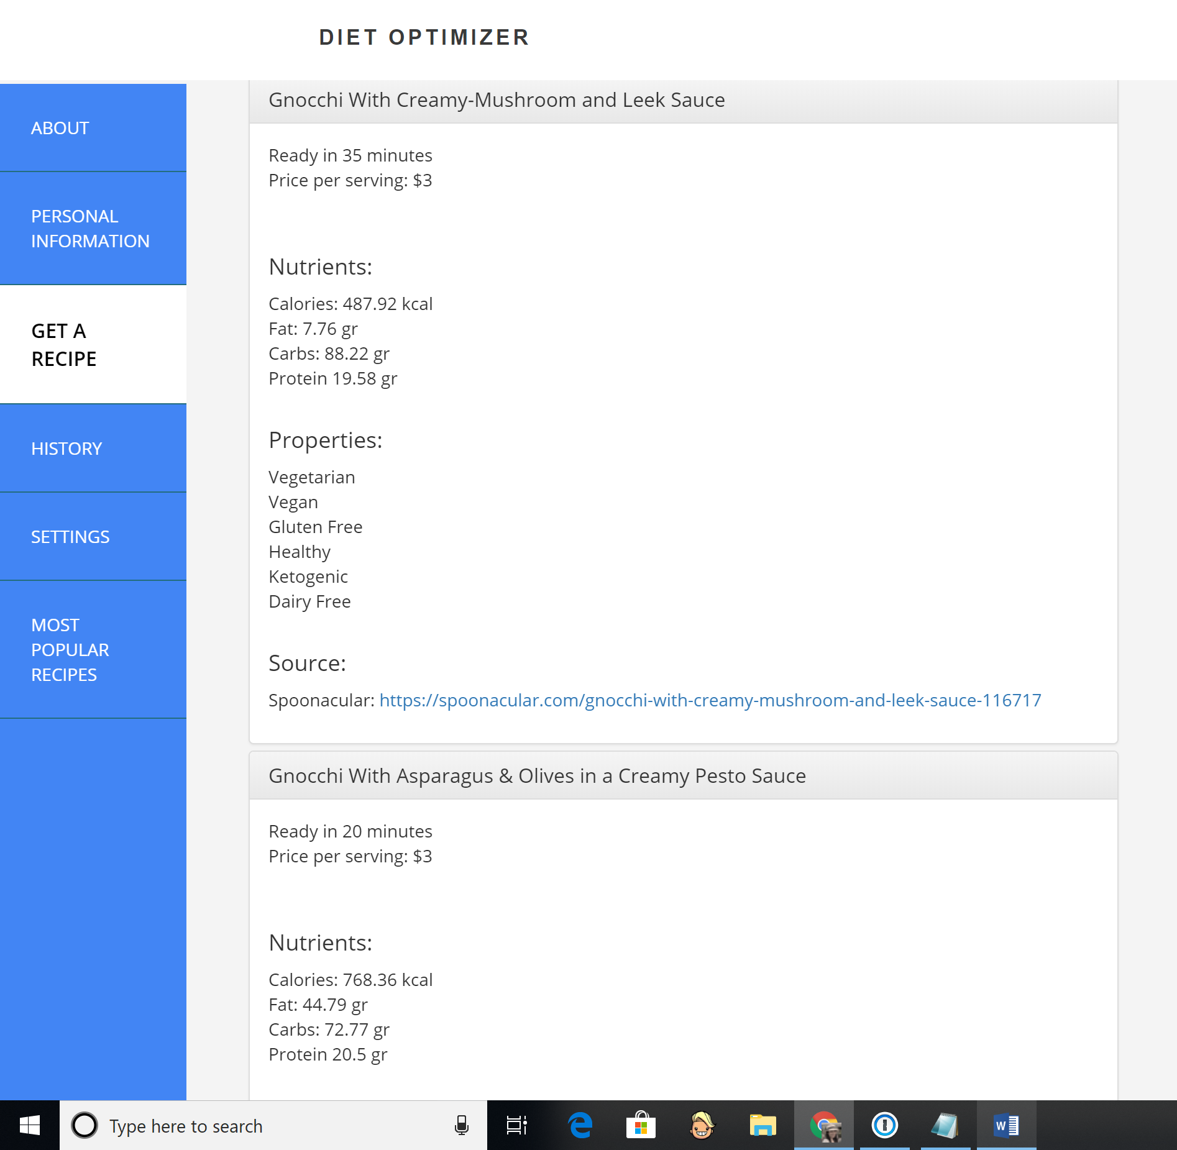
Properties algorithm needs to be sorted out. Orange Chicken recipe isn’t Vegan nor Vegetarian. Gnocchi recipe isn’t Gluten Free.

Really liked the Price and Prep time. Affordability and time constrain are concerns for many.
Who are the users of the Diet Optimizer? Assumed that the user is an educated one. Who is aware and objectively searches for food based on macronutrients. Can someone who is not aware or interested in macronutrients use the search engine?

Is there interest in the amount of Calories?

Sites of interest:
https://www.eatthismuch.com/
https://www.noom.com/#/ This is more of a planning service for losing weight. Not an aggregator of recipes. Can be interesting to see what they ask for in profile and what they offer.

