OutPredict: a Method and Tool for Predicting Out-of-sample Data

Abstract

Consider the problem of predicting the expression of some large set of genes in the next time point of a time series across different species. Imagine several data sources for prediction: naïve (the expression value of a gene will be the same in the next time point as in this one), the entire target time series of interest, the entire the target time series of interest plus other data. The other data may consist of a gold standard network, other time series data, steady state data, binding data, or some combination of those. OutPredict is a machine learning method for time series that incorporates ancillary steady state and network data to give a low error on gene expression prediction and does so better than the best state-of-the-art method, DynGenie3. Our software and datasets are available here … [Jacopo, please fill in]

Introduction

This paper focuses on the problem of predicting out-of-sample data because such predictions are testable in an objective way. While we also see a value in the much more popular gene network inference, there is a strong criterion bias in such inference. After all, if a network is formed based on some criterion (e.g. some kind of binding criterion) and some method predicts more edges based on the same criterion, then one is left wondering whether that criterion in fact important. Importance to us should be based on phenotypic testability: can we predict expression in data we have never seen? That is the primary goal of OutPredict.

Modeling gene expression data is challenging because of the non-linearity of regulatory relationships among genes, the noisiness and incompleteness characterizing genomic data, and the small number of samples relative to the large number of genes.
The small data sizes exclude neural networks and the non-linearity excludes linear methods. Fortunately, Random Forests can model non-linear functions and interacting synergistic influences of features, even with modest data. For these reasons, OutPredict uses Random Forests consisting of an ensemble of regression trees and tuned through extensive bootstrap sampling. This paper compares OutPredict with a state-of-the-art random forest method DynGenie3 both at predicting out-of-sample data in one or more time series, both in situations when other data is available and when it isn’t.

Data
We test our tool on four different species: i) a Drosophila time-series dataset ii) two Arabidopsis datasets: (iia) one in root tissue and (iib) one in shoot tissue iii) a Bacillus subtilis dataset iv) the DREAM4 one-hundred node in silico challenge.
Drosophila melanogaster (Hooper, S. D. et al. 2007): this dataset consists of gene expression levels measured over the 24-hours period during which the embryogenesis of the fruitfly Drosophila takes place. We used as gold standard network data the experimentally confirmed binding interactions between TFs and genes that have been curated in the DroID database (Murali, T. et al. 2011)
Arabidopsis thaliana in Roots (Canales, J. et al 2014): this dataset consists of gene expression levels in response to nitrate treatments in Arabidopsis thaliana root organs. We used as gold standard network data a genome-scale association network constructed based on diverse data types (Lee, T. et al. 2015).
Arabidopsis thaliana in Shoots (Varala, K. et al. 2018): this dataset consists of gene expression level measured over the 2-hours period during which the plants are treated with Nitrogen. We used as gold standard network data a combination of three different datasets: we intersected experimentally regulated genome-wide targets of four regulators of N uptake/assimilation--HHO5, HHO6, PHL1, TGA1 (Varala, K. et al. 2018)--with available TF-target binding data (DAP-Seq, Bartlett, A. et al. 2017), then we further filtered the gold standard with genome-wide DNase I hypersensitivity (DHS) mapping (Sullivan, A. et al. 2015).
B. subtilis: This dataset consists of time-series and steady state data capturing the response of B. subtilis to a variety of conditions (Nicolas et al. 2012). The gold standard network data comes from SubtiWiki, which is repository of information for B. subtilis (Lammers, C. et al 2010; Florez, L. et al. 2009)
DREAM4: A synthetic dataset from the DREAM4 competition, consisting of 100 genes and 100 TFs (any gene can be a regulator). (Greenfield, A. et al. 2010) [Jacopo: describe the gold standard network data]

Dataset | Time-points | Time-series | Steady-State points | Genes | TFs | Edges in gold standard (TFs)
Drosophila | 28 | 1 | 0 | 1000 | 14 | 1660 (9)
Arabidopsis-Roots | 24 | 4 | 107 | 2286 | 263 | 35 (81)
Arabidopsis-Shoots | 54 | 6 | 0 | 2173 | 162 | 167 (4)
B.subtilis | 163 | 33 | 106 | 4218 | 239 | 3144 (154)
Dream | 220 | 20 | 201 | 100 | 100 | 176 (30)
Table1: Datasets description

Methods
The goal of our approach is to learn a function from the gene expression of one time point to predict the gene expression of the next time point. The machine learning techniques we use are based on random forests which have been used previously in [Genie3 - Huynh-Thu et al. 2010, iRafNet - Petralia et al. 2015, DynGenie3 - Huynh-Thu et al. 2018]. Random forests can handle linear and non-linear functions and require much less data than neural networks.
When used on the target time series, the random forests are trained on all consecutive pairs of time points except the last time point. For example, if there are seven time points in the target time series, then the random forest is trained based on the transitions from time point 1 to 2, 2 to 3, …, 5 to 6. Time point 7 will be predicted based on the trained function when applied to the data of time point 6.
When other target time series are included in the training, OutPredict trains the random forest on all consecutive pairs of time points across all time series, except that the random forest excludes the last time point of each time series. The result of the training is to construct a single function f that applies to all time series. To test the quality of function f, we evaluate the mean-squared error (MSE) on the last point of every time series.
When there is steady state or gold standard network data, OutPredict works similarly to the iRafNet package, implemented using scikit-learn. Like iRafNet, when a model is trained, OutPredict treats one dataset (e.g. the target time series data) as the main input data for Random Forest inference while the other $S$ datasets (e.g. steady state data) are utilized as prior knowledge.
In contrast to iRafNet which tries to infer Gene Regulatory Networks and is able to handle only steady state data as the main input data for the Random Forest and time series are only used as priors. OutPredict, instead, predicts out-of-sample data on a single time series by itself or both time series and steady-state expression data combined.
As another point of contrast, iRafNet combines all of the $S$ datasets together to derive prior information and prior datasets are equally weighted. This equal weighting strategy may penalize the overall performance when one particular prior dataset is less informative or error-rich. To overcome this issue our enhanced iRafNet framework separately integrates each prior dataset (in $S$) into the main input learning data by learning weights. Additionally, our new implementation multiplies the feature importance score by the prior feature-weights, introducing an informed bias.

Mathematical Formulation
Let $k$ be the number of features (i.e. transcription factors), $p$ the number of target genes and N the number of training samples; the training dataset is expressed as
$$\{x_{i},y_{i}\}_{i=1}^{N}$$
where $x_{i}∈R^{k}$ denotes the expression values of the transcription factors(TFs) and $y_{i}∈R^{p}$ denotes the expression values of target genes in the $ith$ sample. Our goal is to infer a function: $F:R^{k}->R^{p}$ that fits $\{x_{i},y_{i}\}_{i=1}^{N}$. Jacopo please fill in the blanks: For steady state data the x represents … and the y represents … For time series, the x represents … and the y represents ….
During the tree construction, OutPredict’s Weighted Random Forest, at each node, selects $k$ candidate features (which, in our case, are transcription factors) $X_{1},X_{2},.....,X_{k}$ according to the prior weights, as shown in Fig. 1.
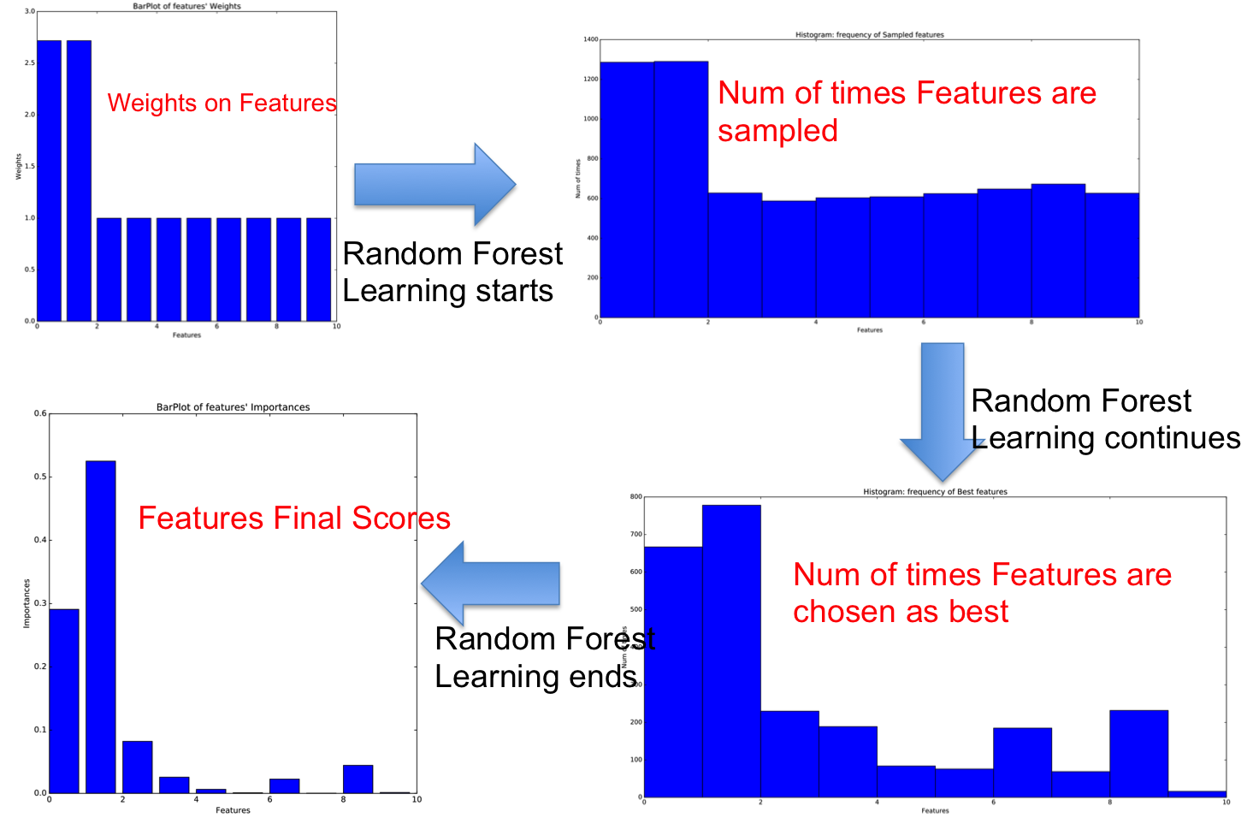
Figure 1: How priors are used: Simple Toy Example of one Gene Model with 10 features (i.e. Transcription Factors) where prior information indicates that two genes should have the greatest influence
Furthermore, at a given node $d$, OutPredict multiplies the importance measure defined as the total reduction of the variance of $y$ [Breiman, 1984] by the weight given by the priors. [Jacopo: It’s not at all clear to me that this is a good idea. The above favoritism should be enough.] Here is the formula used:
$$I(d)=[S_{num}*v_{y}(S)-S_{l_{num}}*v_{y}(S_{l})-S_{r_{num}}*v_{y}(S_{r})]*w_{X_{i},y}$$
where d is the current decision node being evaluated, S is the subset of samples that are below decision node d in the tree, $S_{l}$ and $S_{r}$ are the subsets of experiments on the left and right branches of decision node d, respectively, as defined by [Breiman, 1984]; $var_{y}$ is the variance of the target gene in a given subset, and $S_{l},S_{l_{num}},S_{r_{num}}$ denote the number of experiments in its associated subset.
$w_{X_{i},y}$ is the prior weight from a given feature $X_{i}$ to a given target gene $y$, which allows features with high prior weights, to be chosen with higher probability as branch features (during the tree construction).
Moreover, let $D$ be the set of nodes of the whole ensemble, the overall importance score of the feature $X_{i}$ is:
$$s_{i}=\frac{1}{T}\sum_{D}{I(d)}$$
[Jacopo: why is this paragraph relevant?] The final variable importance value is more robust than the one of a single tree because of the variance reduction resulting from averaging the score for all the trees (Breiman, 1984).

Implementation
OutPredict is parallelized over the different target genes and implements a gene-by-gene hyper-parameter optimization, in order to find the best set of hyper-parameters for each target gene. Our framework allows the use of one of two different types of genomic data as the “main" input datasets (where the last time-point of each time-series will be used for out-of-sample predictions): i) time-series, ii) time-series and steady-state combined as a single dataset and two datasets from which we will take priors: i) gold-standard (GS) network, and ii) steady-state [Jacopo: I’m not sure I understand the above, because you are using the term prior in a very special way. So see if this is correct: As noted above, OutPredict models all time series data together using a Random Forest. OutPredict uses gold standard network data to influence the importance measure as described above. We denote such an influence on importance measure as a “prior” use. OutPredict uses steady state data in two ways: OutPredict can be incorporate steady state data into the same Random Forest Model as the time series data (the “integrated” use) or OutPredict can be incorporate steady state data into a separate Random Forest model which will then be used to influence the importance measure (the “prior” use).
When steady-state data are used as prior information, the feature importance scores resulting from a Random Forest model are used as weights to bias the training of a new Random Forest Model. In this scenario, our framework is a pipeline composed of a sequence of two RF models, where the output of one RF (from the prior dataset(s)) is the input of the second RF (for the main time series data). In order to measure the performance of our algorithm we use Mean Squared Error(MSE) to measure the accuracy of predicting out-of-sample data.
When the gold-standard network is used as the prior, the weights of the true positive edges are arbitrarily assigned to 2, the remaining negative edges are set to 1. [Jacopo: we need to justify this]

Results
For each species tested, we compare the performance of the different combinations of priors and main input datasets (i.e. time series, steady state, etc) and ultimately select the combination giving the highest accuracy.
However, we further evaluated our Weighted RF with the state-of-the-art algorithm DynGenie3 (Huynh-Thu, V. et al. 2018), which is an extension of Genie3 (Huynh-Thu, V. et al. 2010) that is able to handle both steady state and time-series experiments through the adaptation of the same ordinary differential equation (ODE) formulation as in the Inferelator approach (Greenfield, A. et al. 2013).
DynGenie3 was primarily designed for Gene regulatory network inference, yet the authors show the performances of DynGenie3 at predicting both time-series and steady-state data in the cross-validation sets. Therefore, we evaluate dynGenie3 for predicting leave-out time-series data in order to compare it with our framework.
Our mechanism consistently outperforms DynGenie3 with a substantial relative improvement on average, across species, i.e. regardless of the data available (Fig. 1-6).
Furthermore, our system allows us to do out-of-sample prediction well and much better than the naïve approach (which predicts that the next expression value of a gene g in a time series will equal the current expression value).
Moreover, our findings show that models based solely on gene expression (i.e. No-priors) [Jacopo: let’s call these “integrated”] give essentially the same accuracy as models using the weights/importance found in steady-state data (PriorSS, short for PriorSteadyState) and gold standard data (PriorGS, short for PriorGoldStandard). One slight exception is the case of Arabidopsis Shoots dataset (Figure 4). We are frankly puzzled by the little help that gold standard network data provides in predicting gene expression.
By contrast, when OutPredict incorporates steady state data into the random forest with time series, the performance sometimes improves. In fact, the combination of steady state with time-series into a single dataset is very helpful in DREAM4 (Fig. 6) and in Bsubtilis (Fig. 5) but not in Arabidopsis-Canales (Fig. 3). [Jacopo: talk about fruit fly] This could potentially be explained by the multiple differences that exist between the organisms and datasets, such as differences in the dynamics of the gene expression regulation or in the rates at which expression levels are sampled.

Figure 2-6: Experimental Results. Histograms’ figures explanation: in all of the figures, each bar represents a model for a species with a specific main input dataset and a prior dataset (i.e. using data for priors means put weights on creation of a future random forest).
1. Priors:
- TSonly_PriorSS: Steady State data used as priors to bias the random forest created for the time series.
- TS+SS_PriorGS: Steady State [Jacopo: do you mean gold standard used as priors] data used as priors to bias the random forest created for the time series and steady state
2. No Priors:
- TSonly_NoPriors: Time series alone
- TS+SS_NoPriors: Time series with steady state all in one big random forest
3. DynGenie3
4. Naïve: the second to last time points of each time series is used as prediction.
Drosophila
Figure 2: Drosophila Time Series prediction. The vertical axis indicates Mean Square Error, so lower bars are better. In this case, OutPredict performs better than Naïve or dynGenie3 but neither steady state nor gold standard data is helpful.

Arabidopsis in roots
Figure 3: Canales dataset, Arabidopsis in root tissue. The vertical axis indicates Mean Square Error, so lower bars are better. As for Drosophila, OutPredict performs better than Naïve or dynGenie3 but neither steady state nor gold standard data is helpful.

Arabidopsis in shoots
Figure 4: Arabidopsis in Shoot Tissue, Time Series only. [Jacopo: how could the mean squared error be so different than in roots.]

B. Subtilis
Figure 5: Bacillus Subtilis. The vertical axis indicates Mean Square Error, so lower bars are better. OutPredict performs better than Naïve or dynGenie3 and steady state data is helpful. Naïve does surprisingly well.

DREAM4
Figure 6: DREAM4. The vertical axis indicates Mean Square Error, so lower bars are better. As in B Subtilis, OutPredict performs better than Naïve or dynGenie3 and steady state data is helpful. Naïve does surprisingly well.

References [Jacopo: give all the names in these references and make sure the paper format conforms to the paper format for the journal]
Breiman, Leo. 2001. “Statistical Modeling: The Two Cultures (with Comments and a Rejoinder by the Author)”. Statistical Science 16 (3). Institute of Mathematical Statistics: 199–231. doi:10.1214/ss/1009213726.
Greenfield, Alex, Aviv Madar, Harry Ostrer, and Richard Bonneau. 2010. “DREAM4: Combining Genetic and Dynamic Information to Identify Biological Networks and Dynamical Models”. Edited by Mark Isalan. PLoS ONE 5 (10). Public Library of Science (PLoS): e13397. doi:10.1371/journal.pone.0013397.
Petralia, Francesca, Pei Wang, Jialiang Yang, and Zhidong Tu. 2015. “Integrative Random Forest for Gene Regulatory Network Inference”. Bioinformatics 31 (12). Oxford University Press (OUP): i197–i205. doi:10.1093/bioinformatics/btv268.
Huynh-Thu, Vân Anh, Alexandre Irrthum, Louis Wehenkel, and Pierre Geurts. 2010. “Inferring Regulatory Networks from Expression Data Using Tree-Based Methods”. Edited by Mark Isalan. PLoS ONE 5 (9). Public Library of Science (PLoS): e12776. doi:10.1371/journal.pone.0012776.
Maduranga, D. A. K., Jie Zheng, Piyushkumar A. Mundra, and Jagath C. Rajapakse. 2013. “Inferring Gene Regulatory Networks from Time-Series Expressions Using Random Forests Ensemble”. In Pattern Recognition in Bioinformatics, 13–22. Springer Berlin Heidelberg. doi:10.1007/978-3-642-39159-0_2.
Breiman, Leo. 1984. “Classification and Regression Trees.”. In . Chapman & Hall/CRC.
Nicolas, P. et al. 2012. “Condition-Dependent Transcriptome Reveals High-Level Regulatory Architecture in Bacillus Subtilis.”. In Science.
Marbach, Daniel et al. 2012. “Wisdom of Crowds for Robust Gene Network Inference.”. In Nature Methods.
Sullivan, A. et al. 2015. “DNase I hypersensitivity mapping, genomic footprinting, and transcription factor networks in plants.”. In Current Plant Biology.
Bartlett, A. et al. 2017. “Mapping genome-wide transcription-factor binding sites using DAP-seq.”. In Nature Protocol.
Varala, K. et al. 2018. “Temporal transcriptional logic of dynamic regulatory networks underlying nitrogen signaling and use in plants”. In PNAS.
Hooper, S. D. et al. 2007. “Identification of tightly regulated groups of genes during Drosophila melanogaster embryogenesis.” In Mol. Syst. Biol.
Florez, L. et al. 2009. “A community-curated consensual annotation that is continuously updated: the bacillus subtilis centred wiki subtiwiki.” In Database.
Lammers, C. et al 2010. “Connecting parts with processes: Subtiwiki and subtipathways integrate gene and pathway annotation for bacillus subtilis.”. In Microbiology.
Canales, J. et al 2014, “Systems analysis of transcriptome data provides new hypotheses about Arabidopsis root response to nitrate treatments.”. In Frontiers in Plant Science.
Lee, T. et al. 2015 “Aranet v2: an improved database of co-functional gene networks for the study of arabidopsis thaliana and 27 other nonmodel plant species.”. In Nucleic Acids Res.
Murali, T. et al. 2011 “DroID 2011: a comprehensive, integrated resource for protein, transcription factor, RNA and gene interactions for Drosophila.”, In Nucleic Acids Res.
Huynh-Thu, Vân Anh et al. 2018 “dynGENIE3: dynamical GENIE3 for the inference of gene networks from time series expression data”. In Scientific Reports.
Greenfield, A. et al. 2013, “Robust data-driven incorporation of prior knowledge into the inference of dynamic regulatory networks”. In Bioinformatics.

