The notes for September 27th
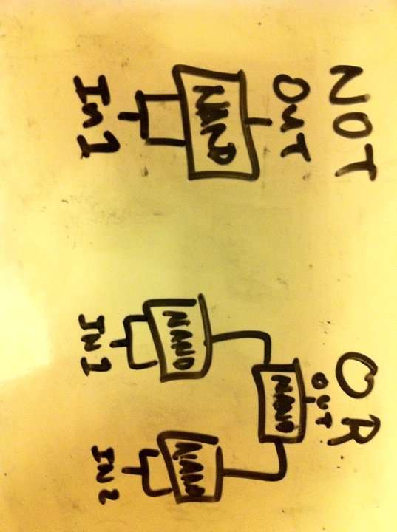
We started off the class by discussing logic gates, the AND and NAND gates in particular. The AND gate returns 1 only if both of its inputs are 1. The NAND gate is the opposite of the AND gate in terms of its output. The NAND gate is called the universal gate because every gate can be made from connected NAND gates.
The NOT gate takes one input and returns the opposite of its input.
The OR gate returns 1 as long as at least one of its inputs is 1.

To create logic gates electronically, we use transistors. If the base gets a low signal (0), no current flows from the collector to the emitter, otherwise current may flow form the collector to the emitter. Though physicists often assume proton flow as opposed to electron flow (electrons are the charge carriers actually involved in electricity working), our circuits still work. [Collector and emitter are reversed]
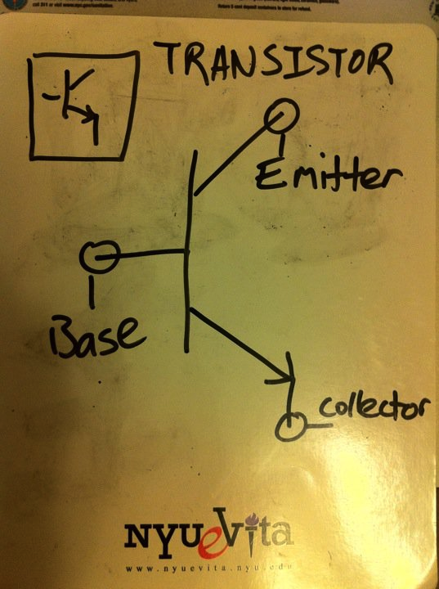
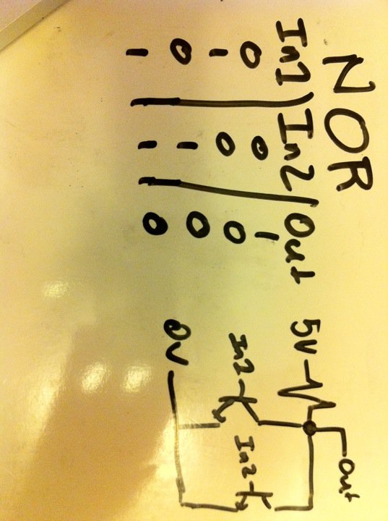
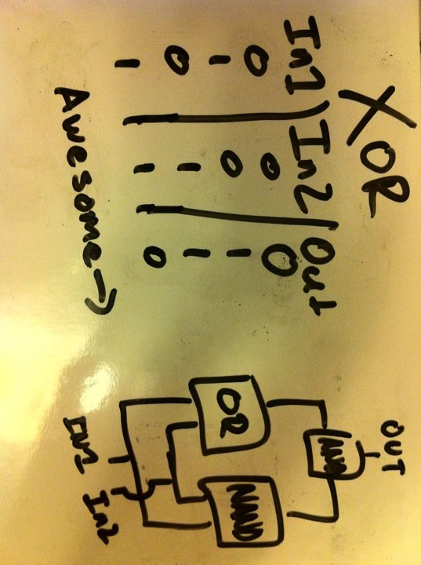
The rest of the class was figuring how to make gates using transistors (with the exception of the XOR, where we used actual gates). [In the and gate below, there should not be a resistor on the top near 5V]

