Red Green and Blue

Level 1:

Mr. Green, Mr. Red and Mr. Blue are each wearing a shirt that
is green, red or blue and pants that are either green, red, or blue.

No man wears the same color shirt and pants.

Also, nobody is wearing the color of his name.

If Mr. Green's shirt is red, Mr. Red's pants are blue, and Mr. Blue's shirt
is green, then what are the colors of all the shirts and pants of each person?
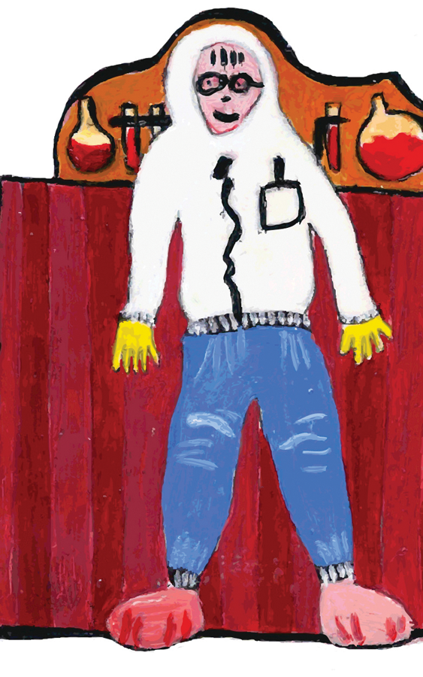
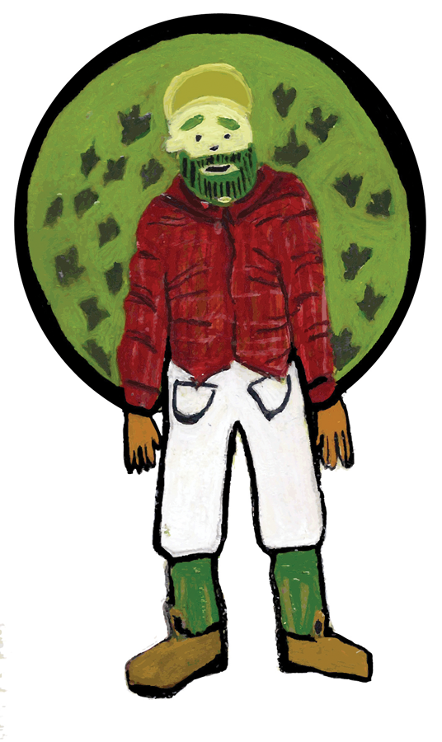

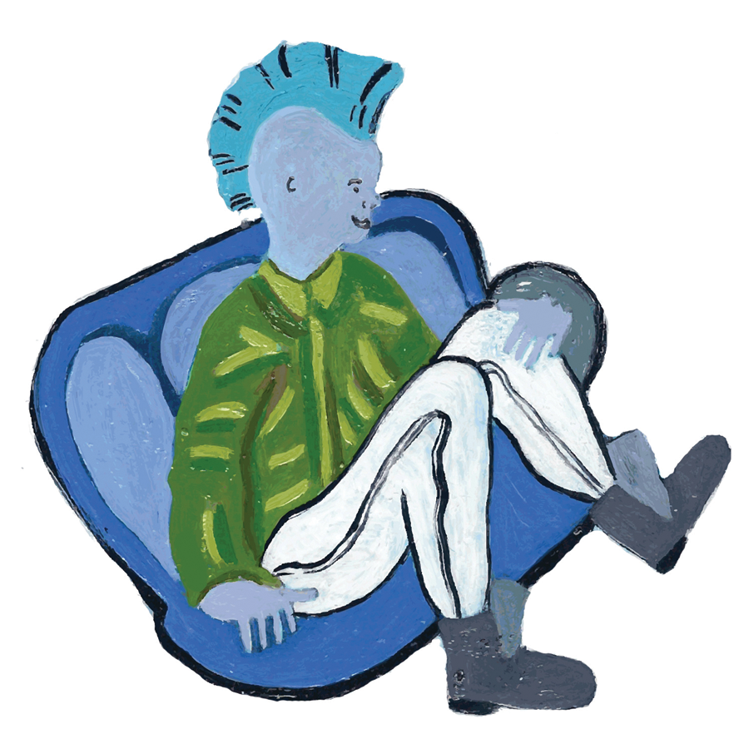

Red Green and Blue

Level 2:

Mr. Green, Mr. Red and Mr. Blue are each wearing a hat, shirt, and pants of different colors.

Among the three there is one green hat, one red hat, and one blue hat, similarly for shirts and pants.

Mr. Green has green pants and Mr. Red has a red shirt.

What are the hat colors of each man?

Level 3:

Mr. Green, Mr. Red and Mr. Blue are each wearing a hat, shirt, and pants of different colors.

Among the three there is one green hat, one red hat, and one blue hat
, similarly for shirts and pants.

Mr. Green wears neither a red shirt nor a blue hat.
Mr. Red wears neither a red shirt nor red pants.

What does each person wear?

Red Green and Blue : Solutions

Megan: this should be the solution to level 1:

- Solution: Mr. Geen must be wearing blue pants because he cannot wear green
- and his shirt is already red. Mr. Red must be wearing a green shirt
- and Mr. Blue must be wearing red pants.

Solution Level 1: level 2
Green: green pants
Red: red shirt.
So, Green cannot wear a green shirt because he has green pants and cannot wear a red shirt because Red has one.
So, Green has a blue shirt and therefore a red hat.

Red cannot wear red pants because he has a red shirt and cannot be wearing green pants, because Green is wearing green pants.
So, Red must have blue pants and a green hat.
These choices determine what Blue wears.

Solution Level 2: This should have been for level 1.
Mr. Green must be wearing blue pants because he cannot wear green and his shirt is already red. Mr. Red must be wearing a green shirt and Mr. Blue must be wearing red pants.

Solution Level 3:
Red must wear a red hat because he wears nothing else red.
Green must wear a green hat, because red is taken and blue is disallowed.
Blue must wear a blue hat by elimination.
Blue must wear a red shirt because neither Green nor Red do.
Blue must wear green pants by elimination.
Red must wear blue pants because he Blue wears green pants and red pants are disallowed.
Red therefore wears a green shirt by elimination.
Green wears a blue shirt.
Green wears red pants.

