Computational Thoughts
Dennis Shasha
09/29/2010
Scribed by: Di Dai

Next Monday schedule: Bringing in Laptop, study Python programming

Discussion on Circuit:
“Or” Circuit (slight change comparing to Circuit ‘Nor’)

IN 1 | IN 2 | OUT
0 | 0 | 0
1 | 0 | 1
0 | 1 | 1
1 | 1 | 1
FIGURE 1:
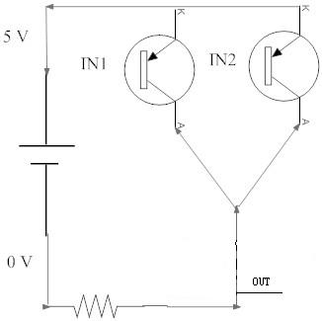
“XOR” Circuit

IN 1 | IN 2 | OUT
0 | 0 | 0
1 | 0 | 1
0 | 1 | 1
1 | 1 | 0
FIGURE 2 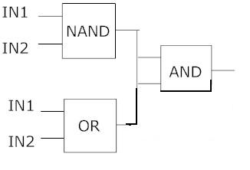

Boolean Algebra: zThe output of the NAND and the output of the OR should not touch one another.

(IN1+IN2)*(NOT“IN1*IN2”)=(IN1+IN2)*(NOT“IN1”+NOT“IN2’)
=(IN1*NOT“IN2”+IN2*NOT“IN1”)

PS: NOT“IN1+IN2”=NOT“IN1”*NOT“IN2”

IN1*NOT“IN2”+IN2*NOT“IN1” Below: output of two ANDs should not be connected.

FIGURE 3: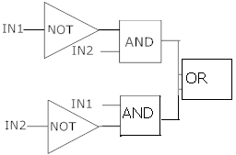

FIGURE 4: (DAVID’s GRAPH FOR XOR) Looks right. Please check with him. dmi216@nyu.edu
